AI-Powered Technical Interview Simulator
Technical Architecture & Implementation Specification
1. System Overview
The AI Interview Simulator is a voice-first platform that allows developers to practice technical interviews tailored to a specific job description (JD).
The platform:
- Parses a Job Description
- Extracts required skills
- Retrieves relevant interview questions using vector search
- Conducts a voice-based interview
- Evaluates answers using RAG (Retrieval-Augmented Generation)
- Provides structured feedback and scoring

2. High-Level Architecture
Frontend (Next.js 14)
│
│ Voice + UI interaction
▼
API Layer (Next.js Route Handlers)
│
├── JD Parsing Service (Gemini)
├── Question Retrieval (MongoDB Vector Search)
├── Interview Session Engine
├── Evaluation Engine (RAG)
│
▼
Data Layer
│
├── MongoDB Atlas
│ ├── Users
│ ├── Interview Sessions
│ ├── Questions
│ └── Vector Embeddings
│
├── Cloudflare R2
│ └── Audio Storage
│
└── Google Cloud
├── Speech-to-Text
└── Text-to-Speech
3. Technology Stack
Frontend
Technology | Purpose
Next.js 14 (App Router) | Application framework
TypeScript | Type safety
Tailwind CSS | UI styling
Lucide React | Icons
Framer Motion | Animations
React Hook Form | Settings forms
Zustand | Interview session state

Backend / AI
Service | Purpose
Gemini 2.5 Flash Lite | LLM inference
Vercel AI SDK | RAG orchestration
Google Speech-to-Text | High accuracy transcription
Google Text-to-Speech | AI interviewer voice

Infrastructure
Service | Purpose
MongoDB Atlas | Database + Vector Store
Cloudflare R2 | Audio file storage
Auth.js / Better Auth | Authentication
Vercel | Deployment

4. Project File Structure
ai-interview-simulator
│
├── app
│ ├── layout.tsx
│ ├── page.tsx
│ │
│ ├── interview
│ │ ├── page.tsx
│ │ ├── session
│ │ │ └── page.tsx
│ │
│ ├── dashboard
│ │ └── page.tsx
│ │
│ └── api
│ ├── jd
│ │ └── parse/route.ts
│ │
│ ├── interview
│ │ ├── start/route.ts
│ │ ├── next-question/route.ts
│ │ └── evaluate/route.ts
│ │
│ ├── audio
│ │ ├── transcribe/route.ts
│ │ └── tts/route.ts
│ │
│ └── rag
│ └── retrieve/route.ts
│
├── components
│ ├── InterviewUI.tsx
│ ├── VoiceRecorder.tsx
│ ├── QuestionCard.tsx
│ ├── ScoreCard.tsx
│ └── SkillChart.tsx
│
├── lib
│ ├── ai
│ │ ├── gemini.ts
│ │ ├── rag.ts
│ │ └── prompts.ts
│ │
│ ├── db
│ │ ├── mongodb.ts
│ │ └── vector-search.ts
│ │
│ ├── audio
│ │ ├── speech-to-text.ts
│ │ └── text-to-speech.ts
│ │
│ └── storage
│ └── r2.ts
│
├── store
│ └── interviewStore.ts
│
├── types
│ ├── interview.ts
│ ├── question.ts
│ └── user.ts
│
├── scripts
│ ├── seed-questions.ts
│ └── generate-embeddings.ts
│
├── config
│ └── rag.config.ts
│
├── .env.example
├── package.json
└── README.md

5. Environment Variables
.env.local
# App
NEXT_PUBLIC_APP_URL=http://localhost:3000
# Gemini
GEMINI_API_KEY=
# MongoDB
MONGODB_URI=
MONGODB_DB=ai_interview
# Vector Search
VECTOR_COLLECTION=questions
# Google Cloud
GOOGLE_CLOUD_PROJECT_ID=
GOOGLE_APPLICATION_CREDENTIALS=
# Speech To Text
GOOGLE_STT_MODEL=chirp_3
# Text To Speech
GOOGLE_TTS_VOICE=en-US-Neural2-C
# Cloudflare R2
R2_ACCESS_KEY_ID=
R2_SECRET_ACCESS_KEY=
R2_BUCKET_NAME=interview-audio
R2_ENDPOINT=
# Auth
AUTH_SECRET=
AUTH_URL=http://localhost:3000

6. API Endpoints
JD Parsing
POST /api/jd/parse
Extract skills from Job Description.
Request
{
"jobDescription": "We are looking for a React developer..."
}
Response
{
"skills": [
"React",
"Next.js",
"TypeScript",
"System Design"
]
}

Interview APIs
Start Interview
POST /api/interview/start
{
"skills": ["React","TypeScript"]
}
Returns retrieved questions.

Get Next Question
POST /api/interview/next-question
{
"sessionId": "abc123"
}

Evaluate Answer
POST /api/interview/evaluate
{
"questionId": "...",
"userTranscript": "My answer is..."
}
Response:
{
"score": 8,
"whatWentWell": "...",
"whatWasMissed": "...",
"refinedAnswer": "A perfect answer would be..."
}

7. MongoDB Configuration
Database
ai_interview

Collections
users
{
_id,
email,
name,
createdAt
}

questions
{
_id,
question,
skill,
difficulty,
goldAnswer,
embedding: [vector]
}

interview_sessions
{
_id,
userId,
questions: [],
answers: [],
scores: [],
createdAt
}

8. MongoDB Vector Search Setup
Enable Vector Index
{
"fields": [
{
"type": "vector",
"path": "embedding",
"numDimensions": 768,
"similarity": "cosine"
}
]
}

9. RAG Architecture
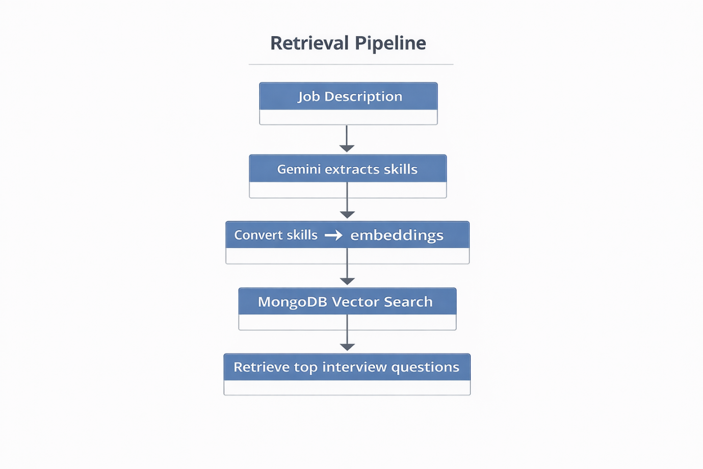
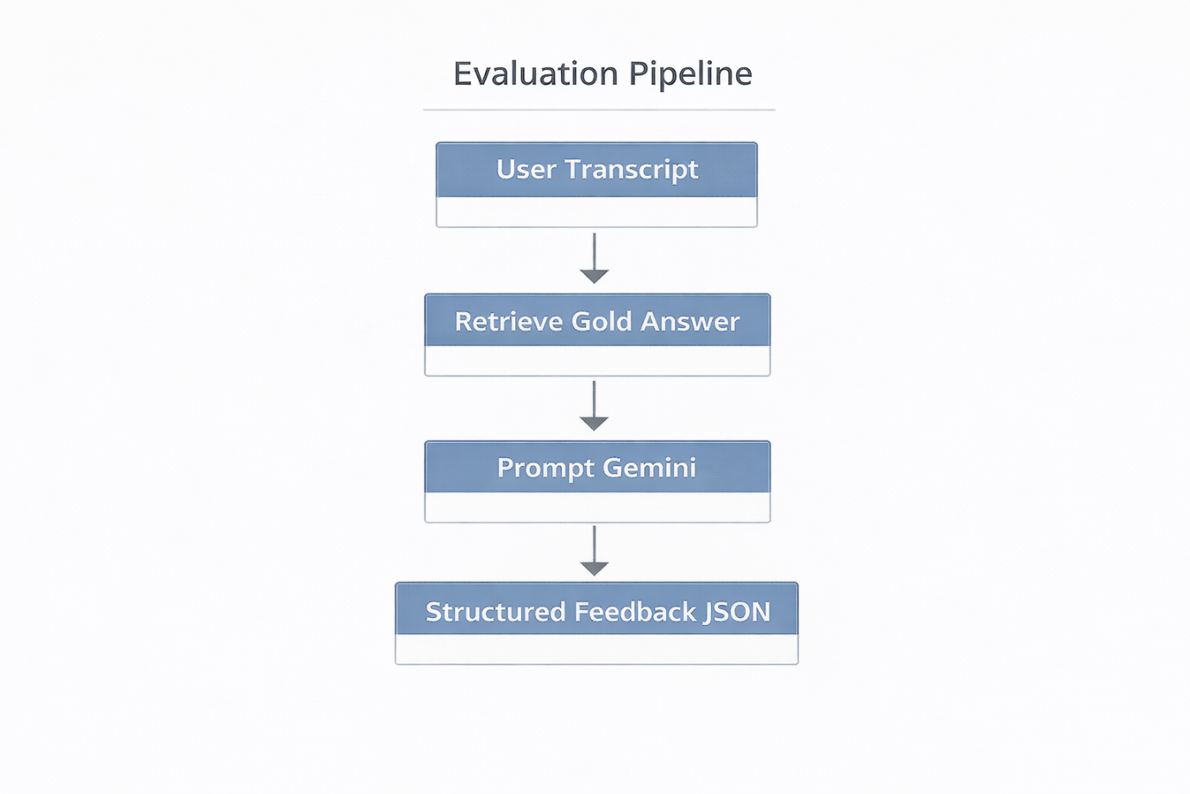

Prompt structure:
You are a technical interviewer.
Compare the candidate answer with the gold answer.
Return JSON:
{
score,
whatWentWell,
whatWasMissed,
refinedAnswer
}

10. Vector Embedding Generation
Script:
scripts/generate-embeddings.ts
Process:
- Load interview questions
- Generate embeddings
- Store in MongoDB
Example:
embedding = gemini.embed(question)
Stored as:
embedding: [0.123, 0.512, ...]

11. Audio Processing Pipeline
Live Captions
Web Speech API
Purpose:
- Instant feedback
- Real-time transcription

Final Transcript
Audio Blob → Google STT (Chirp 3)

AI Voice
Question → Google TTS
Voice:
Neural2

12. Interview Session State (Zustand)
{
sessionId
questions[]
currentQuestionIndex
transcript
recordingStatus
score
}

13. Security Considerations
- Secure API keys via .env
- Auth via Auth.js session tokens
- Rate limit AI endpoints
- Validate JD inputs
- Encrypt audio storage

14. Deployment
Vercel
vercel deploy
Environment variables configured in:
Vercel Dashboard → Project Settings → Environment Variables

15. Future Enhancements
- AI coding challenges
- Resume analysis
- System design interview mode
- Multilingual interviews
- AI coaching suggestions

16. System Design Diagram (Visual Architecture)
End-to-End System Flow
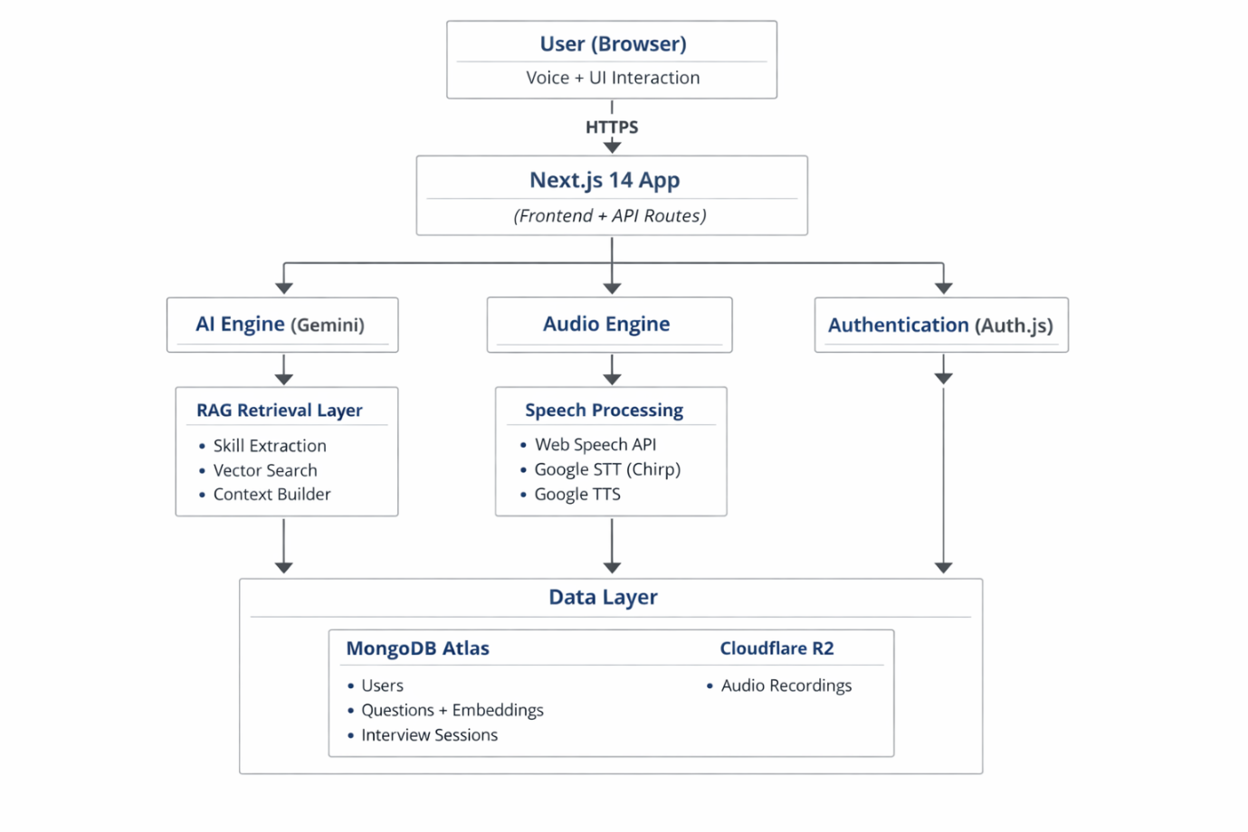
Component Responsibilities
Component | Responsibility
Frontend | Interview UI, recording audio, displaying results
Next.js API Routes | Serverless backend logic
Gemini AI | JD parsing, evaluation, reasoning
MongoDB | Data + vector storage
Cloudflare R2 | Audio storage
Google STT | Accurate speech transcription
Google TTS | AI interviewer voice

Scalability Strategy
The system is designed to scale using serverless architecture:
Layer | Scaling Mechanism
Next.js API | Auto-scale on Vercel
MongoDB Atlas | Auto-sharding and replication
Cloudflare R2 | Globally distributed storage
Gemini API | Managed LLM service

17. Detailed RAG Prompt Engineering Strategy
The project uses Retrieval-Augmented Generation (RAG) to produce accurate, contextual interview evaluations.
The system avoids hallucinations by grounding the LLM using retrieved "Gold Standard Answers".
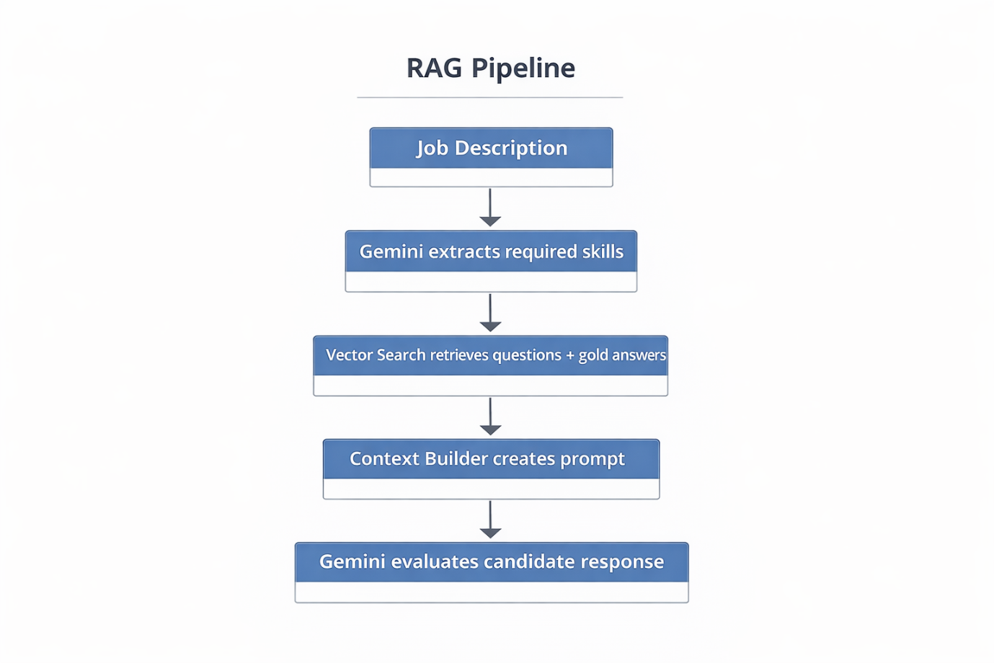

Prompt Design Principles
The prompt follows three important constraints:
- Grounding
The model must reference retrieved answers.
- Structured Output
The model must return JSON.
- Evaluation Focus
The model must act as a senior technical interviewer.
Context Construction
The prompt context includes:
Interview Question
Gold Standard Answer
Candidate Answer
Evaluation Instructions

Example Prompt Template
SYSTEM:
You are a senior software engineering interviewer at a FAANG-level company.
Your job is to evaluate the candidate's answer to a technical interview question.
Use the provided "Gold Standard Answer" as the benchmark.
Be constructive and fair.
Return ONLY valid JSON.
CONTEXT
Question:
{question}
Gold Standard Answer:
{gold_answer}
Candidate Answer:
{candidate_answer}
TASK
Evaluate the candidate response
Return JSON:
{
"score": 1-10,
"whatWentWell": "...",
"whatWasMissed": "...",
"refinedAnswer": "...",
"confidence": 0-1
}

Retrieval Strategy
Vector search retrieves the top 3 most relevant questions.
Ranking formula:
final_score =
0.7 * embedding_similarity +
0.3 * skill_match

Hallucination Mitigation
To prevent hallucinations:
- Force the model to use retrieved answers
- Limit context to top results
- Require JSON output

Prompt Optimization Techniques
Technique | Purpose
Few-shot examples | Improve evaluation accuracy
Temperature = 0.2 | Reduce randomness
Structured JSON output | Easier parsing
Context truncation | Avoid token overflow

18. Database Schema Diagrams & Indexes
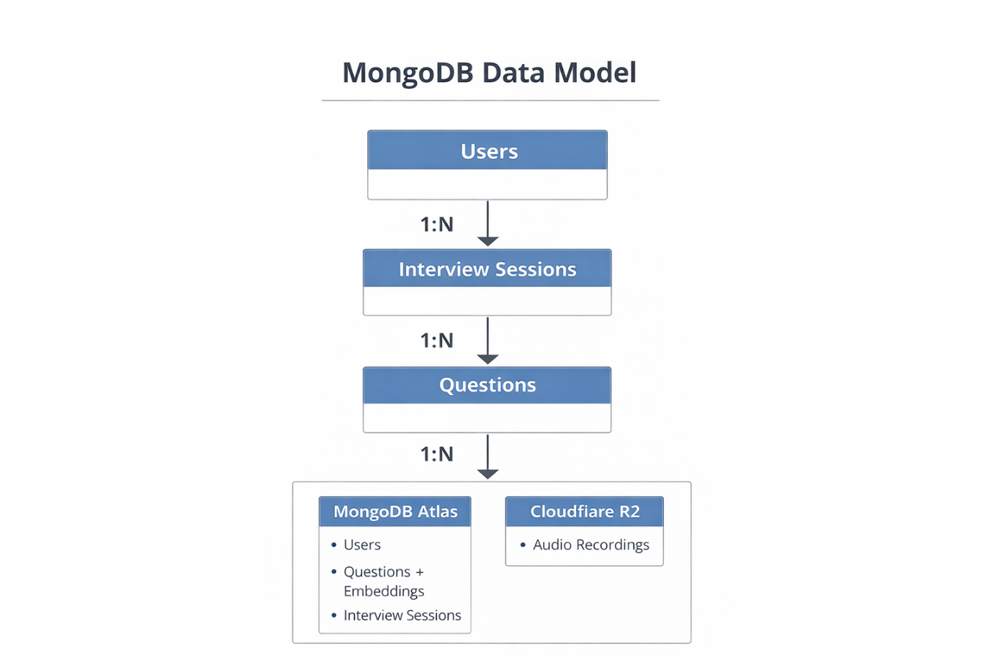
Collection: users
{
_id: ObjectId,
name: String,
email: String,
createdAt: Date
}
Collection: questions
{
_id: ObjectId,
question: String,
skill: String,
difficulty: "easy | medium | hard",
goldAnswer: String,
embedding: [Number],
createdAt: Date
}

Collection: interview_sessions
{
_id: ObjectId,
userId: ObjectId,
questions: [
{
questionId,
questionText
}
],
answers: [
{
questionId,
transcript,
score
}
],
overallScore: Number,
audioUrls: [String],
createdAt: Date
}

Index Strategy
Indexes ensure fast vector retrieval and session queries.

Vector Search Index
collection: questions
field: embedding
dimensions: 768
similarity: cosine

Query Indexes
Questions
db.questions.createIndex({ skill: 1 })
db.questions.createIndex({ difficulty: 1 })

Sessions
db.interview_sessions.createIndex({ userId: 1 })
db.interview_sessions.createIndex({ createdAt: -1 })

Users
db.users.createIndex({ email: 1 }, { unique: true })

Query Optimization Strategy
Query | Optimization
Skill-based question retrieval | skill index
Interview history lookup | userId index
Session timeline | createdAt index
Vector search | MongoDB vector index

Performance Expectations
Operation | Latency
Vector Search | ~50–150 ms
LLM Evaluation | ~1–2 sec
Speech Transcription | ~2–5 sec
Dashboard Query | <100 ms

